Take the Pepsi Challenge

Can YOU tell the difference between Pepsi and Coke?

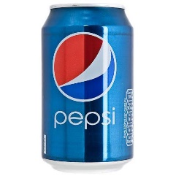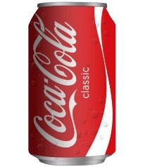

**Name:**

**Gender:**

Please circle the following as appropriate:

**Do you think you will be able to tell which drink is Pepsi?**

Yes No

**In general, which drink would you say you prefer?**

Pepsi Coke No preference

**Which drink is Pepsi?**

A B

**How confident are you that the one you have chosen is actually Pepsi?**

1 – Not at all 2 – Fairly 3 – Very

**Which drink do you actually prefer?**

A B No preference